If you have already created a Family Health History file or if someone has sent you a Family Health History file, you will be able to upload it. Once uploaded, you can open it to see or edit the file. You can also create a copy for yourself or another family member.
You will need to know where the file is saved on your local computer or removable drive. To upload a file:
- Click on the Browse icon. This will open a new window.
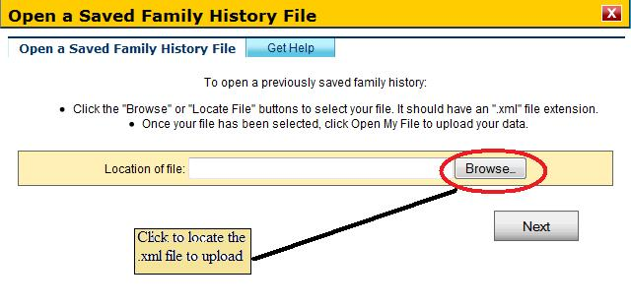
- In the new window, you will have to go the directory that contains the file. The file will be of an “.xml” type.
- Select the file and click on the Open button. This will close the new window.
- In the Open a Saved Family History window, click on the Next button.
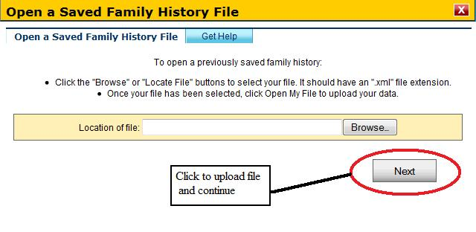
Please note that this site only accepts files of an “.xml” extension and that were created using this site after January, 2009. Any other file types will not be accepted. If you created a family history using this site before January 2009, you will not be able to import that file. Instead, you will need to create a new version by clicking on the Create a Family History button.

